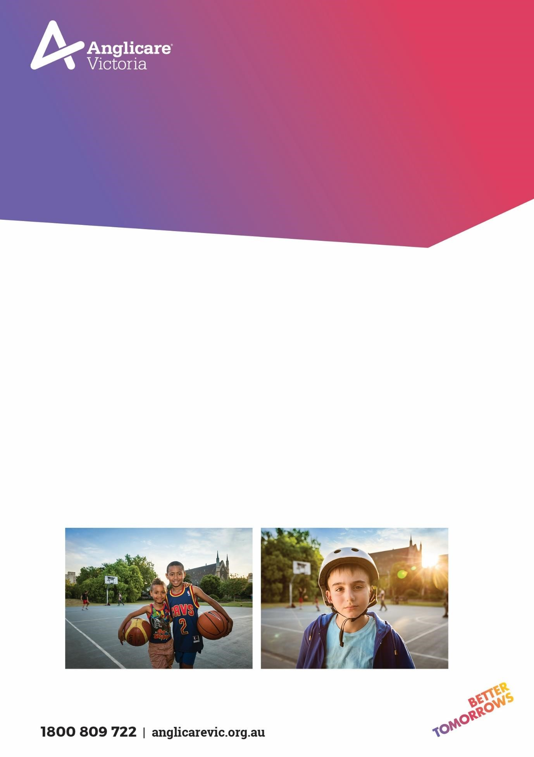

SUBSTANCE USE RECOVE
RY (SURE
)

AOD
COUNSELLING AND ASSE
SSMENT WORKER

POSITION DESCRIPTION

ALCOHOL AND OTHER DR
UG PROGRAM

E
ASTERN

REGION

At Anglicare Victoria our focus is on transforming the futures of
children, young people, families and adults.

Our work is based on three
guiding pillars: Prevent, Protect and Empower
.

We strive to create
an environment where employees feel valued and
rewarded.

By living the Anglicare Victoria values and actively fostering fairness,
equality, diversity and inclusion, our people make Anglicare Victoria a truly
great place to work.

So come and join us at
Anglicare Victoria where there is a rewarding
career ready for you

in a dedicated, professional team where respecting
each other; leading with purpose; working together; and creating a positive
difference are valued, and learning and creativity are encoura
ged
.

Position details
Position | AOD Counselling Clinician
Program | Substance Use Recovery (SURe) AOD Program
Classification | Role will be classified SCHADS Award Level 6.  (Classification will be dependent on qualification and years of experience within the relevant field consistent with the SCHADS Award.)
Hours | Part Time
Hours per week | 22.8 hours per week
Duration | Ongoing
Location | Inner East – Box Hill Office
Reporting  Relationship | This position reports directly to the AOD Team Leader
Effective date | September 2022
Page 2

Overview of program
Anglicare Victoria’s Alcohol and other Drug programs provide counselling, consultancy and continuing care to:
- Individuals with drug and/or alcohol problems 16 years and over.
- Families and friends of individuals with drug and/or alcohol problems.
- Individuals currently involved in the criminal justice system
- Professionals needing assistance in working with and supporting individuals with drug and/or alcohol problems.

The SURe consortia is comprised of Anglicare Victoria and EACH and is a leading provider in the delivery of a broad range of community based Alcohol and other Drug treatment across the Inner East, Outer East and the South East. The reformed integrated AOD catchment based model includes Intake and Assessment, Counselling, care and recovery Co-ordination, Non-Residential Withdrawal and catchment Planning.

Position Objectives

1. | Provide outcome-based counselling.
2. | Conduct comprehensive assessments including mental health screens
3. | Enhance the ability of individuals, family members and significant others including mandated clients to respond to drug and alcohol issues
4. | Develop Individual Treatment Plans for program participants.
5. | Assist clients to work towards harm minimisation strategies

Key responsibilities
The key responsibilities are as follows but are not limited to:

1. | Provide counselling, consultancy and continuing care, assessment, dual diagnosis intervention, support, outreach and referral services to individuals and family members within a harm minimisation framework.
2. | The ability to be flexible and responsive to the needs of the individual in terms of crisis and make the necessary referrals to work collaboratively with other services.
3. | To promote the program throughout the network of referral agencies in the alcohol and drug service delivery sector, the mental health sector, the welfare sector, Protective Services, GPs, hospitals, youth services,  Community Correctional Services and other potential referral sources.
4. | To keep confidential client case notes to ensure effective case management and therapeutic intervention
5. | To engage clients in co-operative and goal directed working relationships and to assist them in achieving positive outcomes by implementing an  Individual Treatment Plan to specifically meet the client and/or family needs.
6. | To maintain up to date records, the relevant data collection methods which all alcohol and drug services are mandated to keep and assist the Team Manager and Program Manager to review and evaluate program performance on a regular basis.
7. | To make a commitment to and actively participate in regular supervision with the Team Manager as required by the Anglicare Victoria supervision policy.

Key Selection Criteria

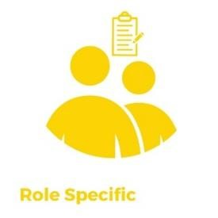 | 1. Tertiary qualifications in a relevant discipline (Psychology, Social Work, Social Science, Counselling) and specifically a minimum of a Cert IV in AOD or Post Graduate Certificate in AOD, including Dual Diagnosis competencies or a minimum 2 years in the AOD sector.
 | 2. Highly developed knowledge, experience and practice in models of contemporary counselling approaches in the alcohol and drug field.
 | 3. Demonstrated ability to work with mandated clients.
 | 4. A demonstrated ability to be receptive and flexible to new ideas and the capacity to adapt to changing work demands and circumstances
 | 5. Good computer, organisational and time management skills and the ability to be self-directed, whist working within a team.
 | 6. Current first Aid certificate required.

Occupational health & safety (OHS)
Anglicare Victoria is committed to ensuring the health and safety of its employees and any other individuals present in our workplaces.
In achieving and maintaining workplace health and safety, Anglicare Victoria will apply best practice in OHS in accordance with statutory obligations at all times. All Anglicare Victoria employees, contractors and volunteers are required to:
- take reasonable care for their own health and safety and for that of others in the workplace by working in accordance with legislative requirements and the company’s OHS policies and procedures
- take reasonable care their actions or omissions do not adversely affect the health and safety of themselves and others
- cooperate with any reasonable directions, policies and procedures relating to health and safety in the workplace
- report all injuries, illness or ‘near misses’ to their Supervisor or Manager
- participate in relevant health and safety training based on roles and responsibilities
- as required, participate in the development and implementation of specific OHS hazard and risk management strategies.
In addition to the above, positions with supervision or management responsibility are required to ensure a safe and healthy work environment for all employees, clients, contractors and visitors. This can be achieved by ensuring all people are aware of and have access to OHS policies, procedures, training and reporting systems

Child Safety Standards
AV is committed to protecting children and young people from all forms of harm and abuse. As an employee you are required to report any concerns raised by, or on behalf of, children and young people in accordance with mandatory reporting, reportable conduct and incident management procedures. Everyone at AV has a role to play in keeping children and young people safe.

Cultural Safety in the Workplace
Anglicare Victoria recognises the important and unique contribution Aboriginal and Torres Strait Islander employees make by bringing their unique skills, knowledge and experience to the workplace. They also contribute important insight into how Anglicare Victoria can provide for and engage with Indigenous clients and communities more effectively.
Our Reconciliation Action Plan (RAP) and Workforce Strategy outlines Anglicare Victoria’s commitment to leading and facilitating sustainable employment, training, retention and career development opportunities for Aboriginal and Torres Strait Islanders people.

Conditions of employment
- Salary and conditions are in accordance with the Social, Community, Home Care and Disability Services Industry Award (SCHADS) 2010. Salary packaging is offered with this position.
- All offers of employment at Anglicare Victoria are subject to a six month probationary period. The staff member will be asked to participate in an annual performance review linked to objectives set out for the position.
- All offers of employment are subject to a satisfactory Criminal History Check, a current Driver’s License, Current First Aid Certificate and an Employment Working with Children Check prior to commencement.
- In line with Anglicare Victoria’s Covid 19 Vaccination Policy we require all staff, students and volunteers to be vaccinated against Covid-19 or hold a valid medical exemption. You will be required to provide evidence that you comply with our policy. Staff are currently required the have two doses of a vaccination and third dose by 12 March 2022, or a valid medical exemption.

Acceptance of Position Description requirements

To be signed upon appointment

Employee
Name:

Signature:

Date:

