Western Region Alcohol and Other Drug Centre Inc

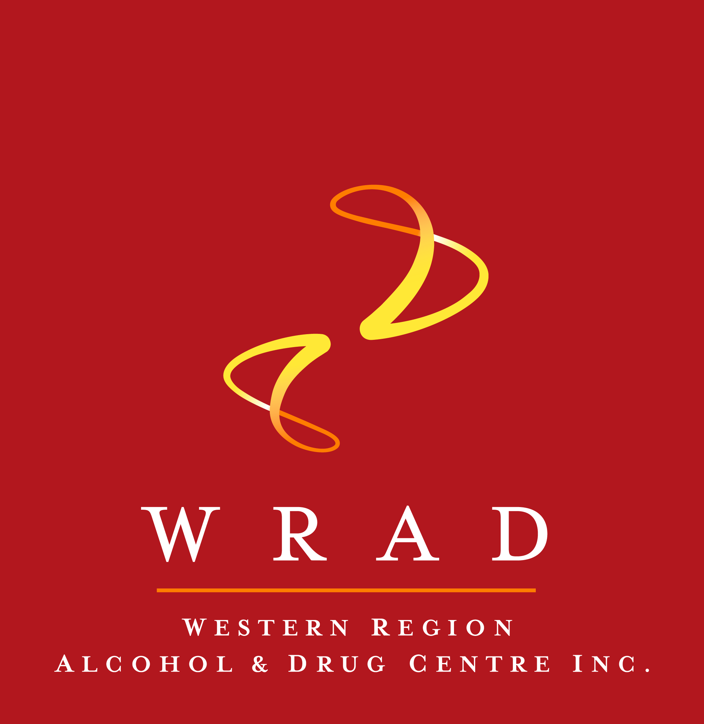

**Have an exciting full-time opportunity on offer for an**

**ALCOHOL AND OTHER DRUG CLINICIAN**

Employer: Western Region Alcohol and Other Drug Centre Inc

Position: Full-time contract to 30/09/2022

Location: Warrnambool

Salary: Competitive remuneration package including Salary Packaging

Award: Health Professional and Support services Award

**Key Tasks:**

* Working with clients to reduce the harm associated with alcohol and other drug use
* Offer counselling to individuals who are concerned about a drug problem
* Liaise with local health and welfare networks
* Provide assessment and reports as required
* Working as part of a multi-disciplinary team
* Record client data on information system

**Qualifications/Experience:**

* A relevant Tertiary qualification is desired or
* Diploma in Community Services or Alcohol and Other Drugs or
* Certificate IV Alcohol and Other Drugs.

WRAD values diversity and believes that a range of backgrounds brings a variety of ideas, perspectives and experiences that will enhance our work. We actively seek to include, welcome and value unique contributions by encouraging Aboriginal and Torres Strait Islander Australians, people with disabilities, people from LGBTIQA+ communities, younger people, older people and people from culturally diverse backgrounds to apply for our positions.

**Position Description:**

Call 1300 009 723 or email [**wrad@wrad.org.au**](mailto:wrad@wrad.org.au)to obtain a copy

**Applications to be made in writing and addressed to:**

**Geoff Soma, Director, WRAD Centre**

**172 Merri Street, Warrnambool 3280**

**or email** [wrad@wrad.org.au](mailto:wrad@wrad.org.au)

**Applications close:** 5 pm on Friday 14th May, 2021