Family Violence Information Sharing
Team Leader Speaking Notes

Session 6: Reflections on what we’ve learned

Purpose of this document
This document is designed to be used by team leaders and sit alongside the PowerPoint slides for each session. Whereas the slides are designed to be shared with team members, this document includes instructions for you about the purpose of each slide as well as suggested speaking notes, where relevant.
We suggest that you review this material ahead of running sessions, and adapt the content as suits your personal style and approach.
This session is a little different from the previous sessions. You won’t be covering any new material and instead will focus on what has been learnt so far and what you can do as a team to keep putting family violence information sharing into practice.
The estimated time required to cover all the content is 45 minutes. If you don’t have this much time available, you could run it in 30 minutes by shortening the group discussions. However, we don’t recommend this as it’s a really important step to make the most of all the hard work everyone has put in over the last five sessions.
Title slide (SLIDE 1)
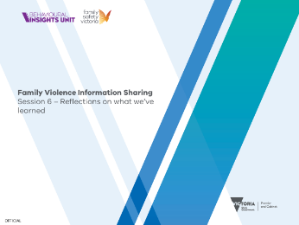

Session agenda (SLIDE 2)
1 minute
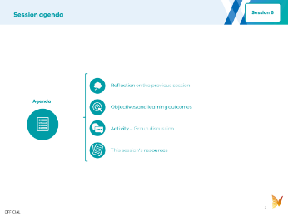

Instructions: Set expectations about what you’ll be covering by running through the agenda with your team.

Reflection on Session 3 (SLIDES 3 and 4)
3 minutes
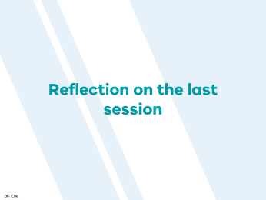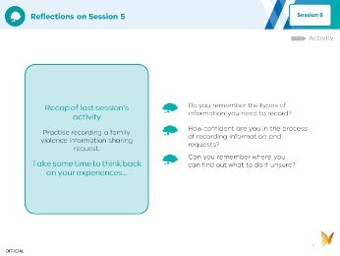

Instructions: To help your team with their learning, you should start this session with a recap and discussion of the activity from last week. Use the discussion prompts on Slide 4 to guide the conversation.

Objective and learning outcomes (SLIDES 5, 6 and 7)
1 minute
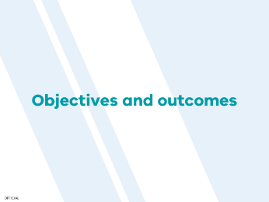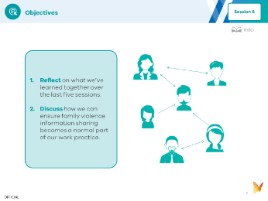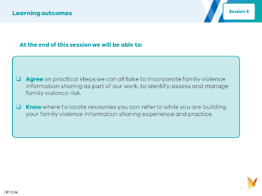

Instructions: Set expectations with your team about the objectives (Slide 6) and learning outcomes (Slide 7) for today.

Session activity (SLIDES 8, 9, 10, 11 and 12)
40 minutes
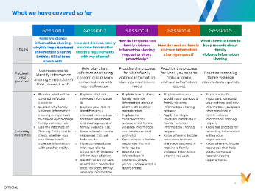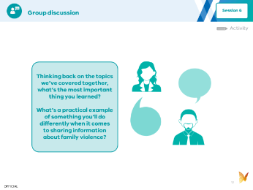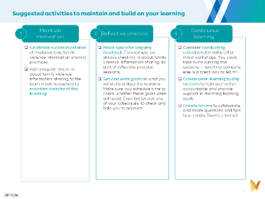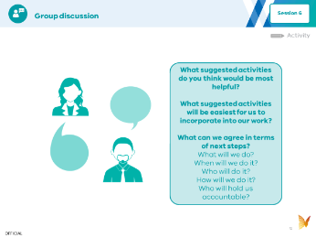
(SLIDE 9 and 10)

Instructions: This is all about reflecting on what has been learnt so far. Your role here is to facilitate discussion. So set the scene and ask open questions to prompt discussion. You might also want to capture key points raised and shared by taking notes.

(SLIDE 11 and 12)

Instructions: This is all about planning how to implement family violence information sharing in your team’s work from now on. Your role here is to facilitate a discussion and also to make sure your team agrees and commits to concrete actions that can be implemented. Make sure any actions clearly outline what, when, who, how and accountability. You should either send around the agreed actions after the session so everyone has a record, or ask someone in your team to do this.

Resources (SLIDE 13 and 14)

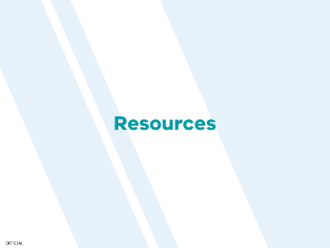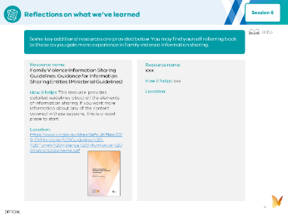

Instructions: These resources are included as they may be helpful to guide you if you need more information about how to make a family violence information sharing request. If you have time, you could run through the list of resources together, but you don’t have to go into them or read them today. They are provided for future reference.

