# **Family Violence Information Sharing Team Leader Speaking Notes**

# **Session 5: What I need to know to keep records about family violence information sharing.**

**Purpose of this document**

This document is designed to be used by team leaders and sit alongside the PowerPoint slides for each session. Whereas the slides are designed to be shared with team members, this document includes **instructions** **for you** about the purpose of each slide as well as **suggested speaking notes**, where relevant

We suggest that you review this material **ahead** of running sessions, and adapt the content as suits your personal style and approach.

**Before you run this session, it’s important to clearly understand your organisation’s process for where to keep records of family violence information sharing requests.** The material includes some general points about what needs to be recorded, but how this is done is up to individual organisations. You’ll need to know these processes in order to run the activity in this session.  
  
The **estimated time required** to cover all the content is **one hour**. If you **don’t have this much time available with your team**, you may wish to **pick and choose** which sections to cover based on the level and experience in your team.   
For example:  
- The **Background** section could be skipped or covered very briefly if your team already understands the basics of what information needs to be recorded and where it is recorded.  
- If your team has good theoretical knowledge but is less confident putting this into practice, then you should place higher priority on the **Activity.**

**Title slide** (SLIDE 1)

## 

## **Session agenda** (SLIDE 2)

1 minute

## 

|  |
| --- |
| **Instructions:** Set expectations about what you’ll be covering by running through the agenda with your team. |

## **Reflection on Session 3** (SLIDES 3 and 4)

3 minutes

## 

|  |
| --- |
| **Instructions:** To help your team with their learning, you should start this session with a recap and discussion of the activity from last week. Use the discussion prompts on Slide 4 to guide the conversation. |

## **Objective and learning outcomes** (SLIDES 5, 6 and 7)

1 minute

## 

|  |
| --- |
| **Instructions:** Set expectations with your team about the objectives (Slide 6) and learning outcomes (Slide 7) for today. |

## **Background - What I need to know to keep records about family violence information sharing** (SLIDES 8, 9, 10, and 11)

10 minutes

## 

|  |
| --- |
| **Instructions:** You can use the following information to introduce your team to this week’s topic. It covers all the key points. You can read aloud the notes below, or adapt them to your own speaking style. The key points are covered in the slides, and further details are provided in the speaking notes below, which expand on some of these key concepts. |

**Suggested speaking notes:**

* **When you need to keep a record**
  + Under the regulations for family violence information sharing, the person sharing information has an obligation to record what is shared and how they respond.
  + However, it is good practice for organisations requesting family violence information to also keep records of what they requested and what information was shared with them.
  + For the purposes of this session, we will be outlining the record keeping obligations for when you **receive** a family violence information sharing request.   
    You should also confirm what practices are expected at your organisation for record keeping when you **make** a family violence information sharing request.
* **What do I need to include in my records?**
  + The exact information you need to record depends on each case. There is some information you will always need to record, while there is information you will only record based on who you are sharing family violence information about.
  + The decision tree on slide 10 helps to map out what needs to be recorded depending on the specific case, and we can run through this together now:
  + For all family violence information sharing requests that we receive we must always record:
    - The name of the ISE that the request came from
    - The date of the request
  + Next you will have to decide whether to share information or refuse this request.   
    **Remember:** We covered the reasons for sharing family violence information in Session 3.
  + If the request is declined, then you will need to record:
    - The reason that the request has been refused
    - It is also good practice to advise the requesting ISE why the request is not being granted. This should be done in writing. This is the end of the reporting requirements if the request is refused.
  + If the information being shared is about only the perpetrator, then this is the end of the information that you need to record.
  + If the information being shared relates to an adult victim survivor or a third party and no children are at risk, then you will also need to record:
    - Whether consent to share family violence information was requested or not
    - If consent was provided, how it was provided (e.g. written, verbal or implied)
    - If consent was not provided.
* **Where and how do I record this information?**
  + **Note to team leaders:** This is an opportunity to walk through your own organisation’s process for keeping records for family violence information sharing requests.
  + As a sense of how record keeping can be managed, some record keeping could be managed through an online record management system or in case notes. The example on slide 11 shows the type of information needed to keep records. As a team leader, this is something that you can show your team if your own record process isn’t able to be displayed.
  + If you do have the opportunity to visually show where and how the record keeping can be kept, it is suggested you do so now, either by sharing your screen (if presenting the session virtually) or by presenting your screen to your team.

## **Session activity** (SLIDE 12, 13 14 and 15)

30 minutes

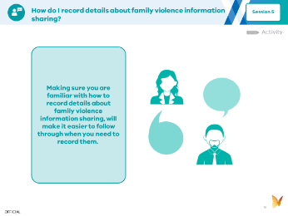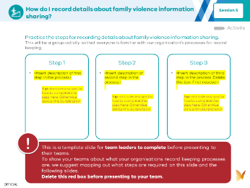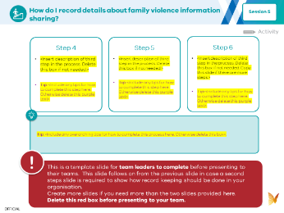

(SLIDE 13)

## 

|  |
| --- |
| **Instructions:**  This week’s activity shows your team how your organisation formally keeps records about family violence information sharing. You will need to do some preparation before the session takes place:  **Understand how your organisation keeps records of family violence information sharing requests.**  This varies from organisation to organisation, but could include keeping records in case notes, having a form to complete and then saving into a record management system, or saving information into a record management system in another way.  **Prepare a demonstration of how you would access and record this information.**  This demonstration may need to be done virtually or face to face depending on how you are running this session. If you are doing it virtually, you may like to share your screen to demonstrate how you access the notes / forms you need, provide a demonstration of completing a form and then save it in an appropriate place.  **In the PowerPoint presentation slides, you will find some placeholder slides for you to complete the details of the activity based on your organisation’s processes.** |

## **Resources** (SLIDE 16, 17 and 18)

## 

|  |
| --- |
| **Instructions:** These resources are included as they may be helpfulif you need more information about how to make a record about a family violence information sharing request or process. If you have time, you could run through the list of resources together, but you don’t have to go into them or read them today. They are provided for future reference. |