Family Violence Information Sharing
Team Leader Speaking Notes

Session 4: How do I make a family violence information sharing request?

Purpose of this document
This document is designed to be used by team leaders and sit alongside the PowerPoint slides for each session. Whereas the slides are designed to be shared with team members, this document includes instructions for you about the purpose of each slide as well as suggested speaking notes, where relevant.
We suggest that you review this material ahead of running sessions, and adapt the content as suits your personal style and approach.
Before you run this session, it’s important to confirm your organisational practice about how you request family violence information from other services to make sure you're providing up to date and clear advice to your team when presenting this material.
The estimated time required to cover all the content is one hour. If you don’t have this much time available with your team, you may wish to pick and choose which sections to cover based on the level and experience in your team.
For example:
- The Background section could be skipped or covered very briefly if your team already understands the basics of how to make a family violence information sharing request.
- If your team are already having conversations with clients about family violence information sharing, you may wish to focus on the Case study instead of the Activity.
- If your team has good theoretical knowledge but is less confident putting this into practice, then you should place higher priority on the Activity.

Title slide (SLIDE 1)

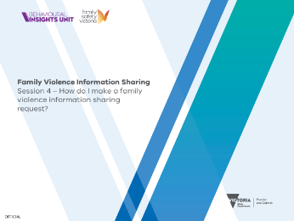

Session agenda (SLIDE 2)
1 minute

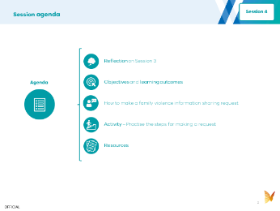

Instructions: Set expectations about what you’ll be covering by running through the agenda with your team.

Reflection on Session 3 (SLIDES 3 and 4)
3 minutes

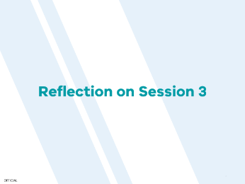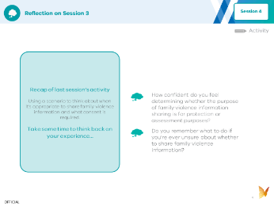

Instructions: To help your team with their learning, you should start this session with a recap and discussion of the activity from last week. Use the discussion prompts on Slide 4 to guide the conversation.

Objective and learning outcomes (SLIDES 5, 6 and 7)
1 minute

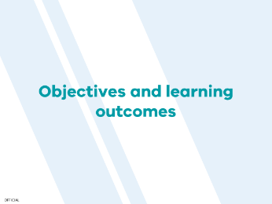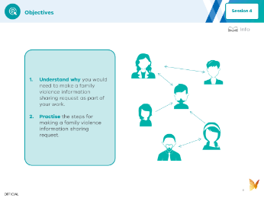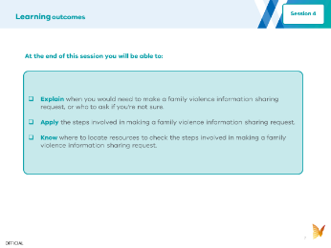

Instructions: Set expectations with your team about the objectives (Slide 6) and learning outcomes (Slide 7) for today.

Background (SLIDES 8, 9, 10, 11 and 12)
10 minutes

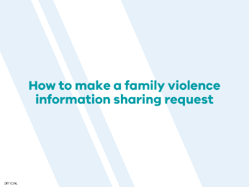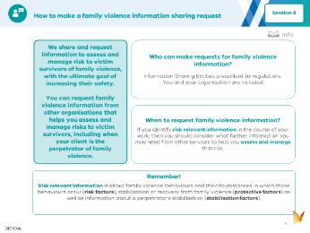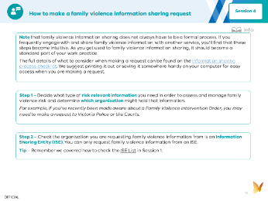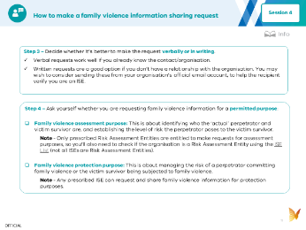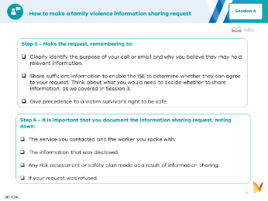

Instructions: You can use the following information to introduce your team to this week’s topic. It covers all the key points. You can read the notes below aloud, or adapt them for your own speaking style. The key points are covered in the sides, and further details are provided in the speaking notes below, which expand on some of the key concepts.
Suggested speaking notes:
- Why we share family violence information
  - We share and request information to assess and manage family violence risk, with the ultimate goal of keeping adult and child victim survivors safe. The Family Violence Information Sharing Scheme provides workers in certain sectors with the ability under law to share information to assess and manage family violence risk.
- Who can make a family violence information sharing request?
  - You are someone who can make a family violence information sharing request because you work in an ISE and you may have access to information that can help to assess or manage family violence risk. For example, you may be in a position where you could hear or observe behaviour that allows you to identify family violence risk (of a perpetrator or victim survivor) and you need to make a request for further information in order to assess and manage that risk. Family violence information sharing can be done inside your own organisation or between organisations.
- When should you request family violence information?
  - You should make an information request using the Family Violence Information Sharing Scheme if you identify risk relevant information as part of your work and need to assess and manage that family violence risk. You don’t need to be working with the victim survivor of family violence to make an information sharing request. You may also be working with a perpetrator of family violence and decide to request information to assess or manage the risk the perpetrator poses to a victim survivor who is not using your service.
Risk Relevant Information
- Refer back to Session 2 for a more detailed explanation of risk relevant information. A summary is provided below:
- Information about family violence behaviours and the circumstances in which those behaviours occur (risk factors) a perpetrator is using against an adult and / or children victim survivors.
- Information related to an adult and / or child's stabilisation and recovery (protective factors) from family violence.
- Information related to a perpetrator’s stabilisation (stabilisation factors).
(SLIDE 9, 10, 11, 12)
Suggested speaking notes:
- Once you know how to request family violence information it is a very easy process to repeat.
- Family violence information sharing does not always have to be a formal process. You may frequently engage with and share information with another service without following a formal process. As you get used to family violence information sharing, it should become a standard part of your work practice.
- We’ll now go through the Steps to run though when making a family violence information request.
Instructions: Follow Steps 1 to 6 on Slides 10, 11 and 12 and run through these with your team. They will have a chance to practise this process in the activity, which is the next thing you’ll cover.

Session activity (SLIDE 13, 14, 15, 16, 17and 18)
30 minutes
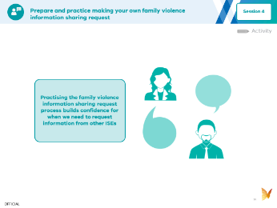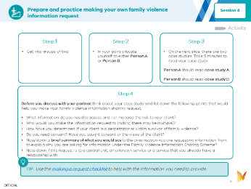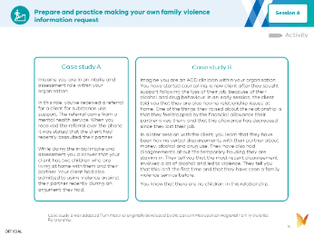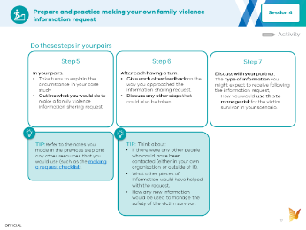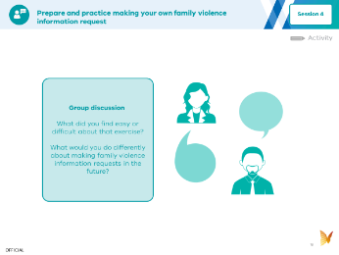
(SLIDE 14)
Instructions: Set the scene for the activity you will be completing as part of the session. This is about practising the process of making a family violence information sharing request using two case studies.
This activity is best done in pairs. Each person in the pair will have a case study each that they will read and use to role play making a family violence information sharing request.

(SLIDE 15, 16, 17)

Instructions: Explain how the activity will work, namely, people will get into pairs, and each person in the pair will focus on a different case study. They will need to assign themselves between either person A or person B and read the case study that matches. There will then be an opportunity for each person to read their case study, followed by an opportunity to think about how they would make a family violence information sharing request based on the scenario in their case study. After this, they will discuss with their partner what they did to make the family violence information request before contributing to a broader group discussion.
If people are having trouble getting started, you may want to allocate people to pairs and move between the groups to observe, help troubleshoot any issues and offer feedback.

(SLIDE 18)

Instructions: To help embed learnings from the activity, it’s a good idea to wrap up with a quick discussion.

Resources (SLIDE 19, 20, 21 and 22)

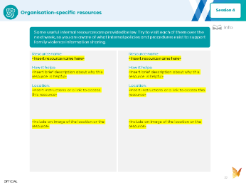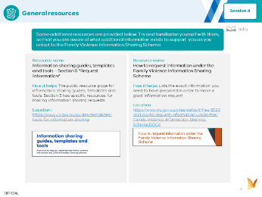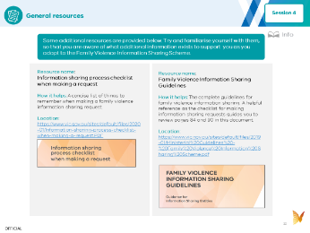

Instructions: These resources are included as they may be helpful if you need more information about how to make a family violence information sharing request. If you have time, you could run through the list of resources together, but you don’t have to go into them or read them today. They are provided for future reference.

