Family Violence Information Sharing
Team Leader Speaking Notes

Session 3: How do I respond to a family violence information sharing request or share proactively?
Purpose of this document
This document is designed to be used by team leaders and sit alongside the PowerPoint slides for each session. Whereas the slides are designed to be shared with team members, this document includes instructions for you about the purpose of each slide as well as suggested speaking notes, where relevant.
We suggest that you review this material ahead of running sessions, and adapt the content as suits your personal style and approach. Before running this session, it’s a good idea to make sure you’re familiar with your organisation’s information sharing policies and procedures.
The estimated time required to cover all the content is one hour. If you don’t have this much time available, you may wish to pick and choose which sections to cover based on the level and experience in your team.
For example:
- The Background section could be skipped or covered very briefly if your team already understands the basics of what to consider when sharing family violence information about a client.
- If your team has good theoretical knowledge but is less confident putting this into practice, then you should place high priority on the Activity and case studies.

Title slide (SLIDE 1)

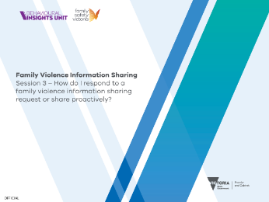

Session agenda (SLIDE 2)
1 minute

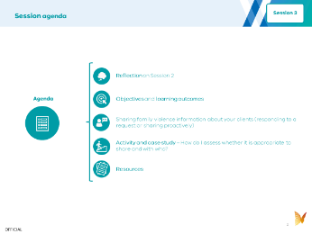
Instructions: Set expectations about what you’ll be covering by running through the agenda with your team.

Reflection on Session 2 (SLIDES 3 and 4)
3 minutes

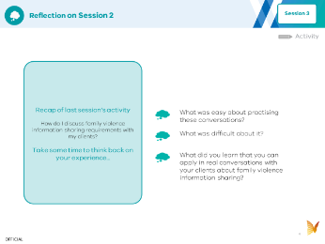
Instructions: To help your team with their learning, you should start this session with a recap and discussion of the activity from last week. Use the discussion prompts on Slide 4 to guide the conversation.

Objective and learning outcomes (SLIDES 5, 6 and 7)
1 minute

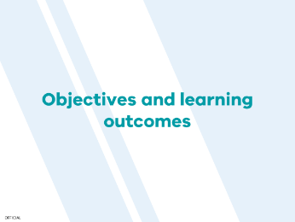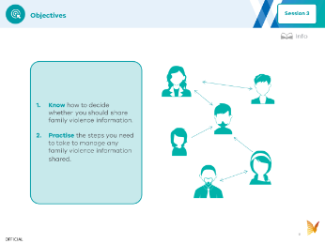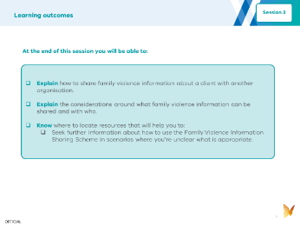
Instructions: Set expectations with your team about the objectives (Slide 6) and learning outcomes (Slide 7) for today.

Background (SLIDES 8, 9, 10, 11, 12 and 13)
10 minutes

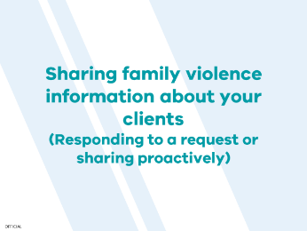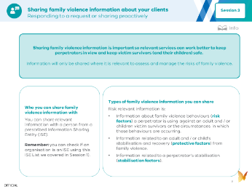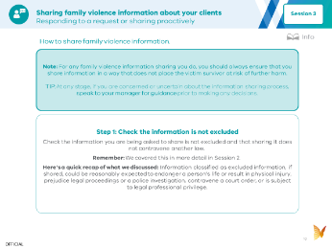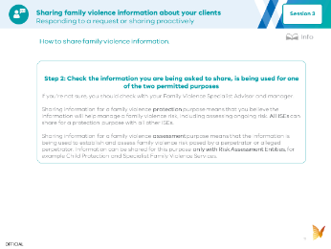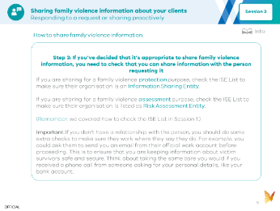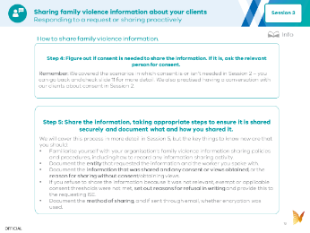

Instructions: You can use the following information to introduce your team to this week’s topic. It covers all the key points. You can read the notes below aloud, or adapt them to your own speaking style. The key points are covered in the slides, and further details are provided in the speaking notes below, which expand on some of those key concepts.
Suggested speaking notes:
- Why we share family violence information about our clients
  - Under the Family Violence Information Sharing Scheme, you may receive a request to share family violence information with another service organisation about one of your clients. You might also share information proactively after identifying family violence risk.
  - Sharing family violence information in this way can help to keep victim survivors safe.
  - Today we’ll cover what you need to consider before deciding whether to share family violence information, and how to share that information.
- Practising the decision-making steps for whether to share family violence information will make it easier for you when you receive a request to share information about one of your clients.
  - Family Safety Victoria has published a helpful decision tree that we can use to guide us through the steps and considerations about whether to share family violence information following an official request. A lot of the considerations should be familiar to you after last week’s session.
- How to share family violence information
  - You will need to make sure you are sharing family violence information securely – we’ll cover this in more detail in Session 5. If you receive an information request before we complete Session 5, please ask me or our Specialist Family Violence Adviser for advice.
  - You will also need to record the information sharing request and how you responded. Again, we’ll cover this in Session 5.
  - We’ll run through the steps to respond to an information sharing request, or to share information proactively. You can find more details in the information sharing process checklist (included in the resources section for this session). It is worth printing this out or saving it to your desktop for future reference.

Session activity and case studies (SLIDE 14, 15, 16 and 17)
40 minutes

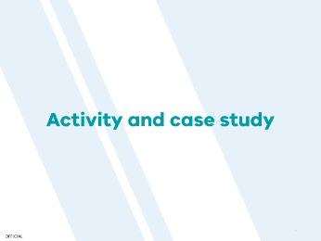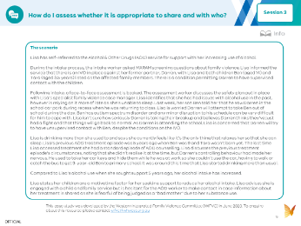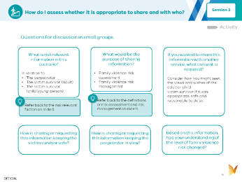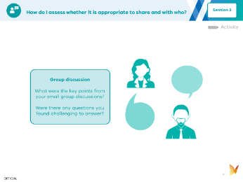
Instructions: Set the scene for the activity you will be completing as part of the session. This is about using a relevant scenario to decide whether you should share family violence information and with whom. Unlike in previous sessions, the activity and case study are combined in this session, so you don’t need to leave extra time to cover the case study afterwards.

(SLIDE 15, 16 and 17)
Instructions: Ask the team to spend 10 minutes reading the case study example provided.
Break up into small groups to discuss the questions for the case study. You should allow about 20 minutes for this (approximately 4 minutes per question).
Use the final 10 minutes to come back together as a large group and share what you discussed.

Resources (SLIDE 18, 19, 20 and 21)

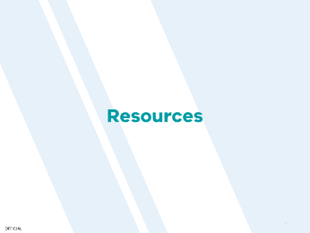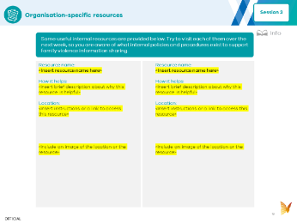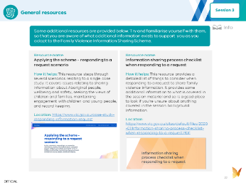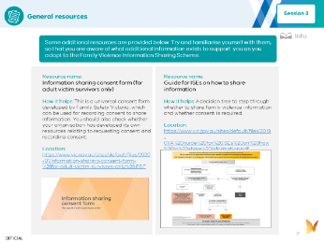
Instructions: These resources are included as they may be helpful to guide you if you need more information about how to share family violence information. If you have time, you could run through the list of resources together to build awareness, but you don’t need to go into them or read them today. They are provided as a future reference.

