Family Violence Information Sharing
Team Leader Speaking Notes

Session 2: Risk relevant information and discussing family violence information sharing with clients

Purpose of this document
This document is designed to be used by team leaders alongside the PowerPoint slides for each session. Whereas the slides are designed to be shared with team members, this document includes instructions for you about the purpose of each slide as well as suggested speaking notes, where relevant.
We suggest that you review this material ahead of running sessions, and adapt the content as suits your personal style and approach.
The estimated time required to cover all the content is one hour. If you don’t have this much time available, you may wish to pick and choose which sections to cover based on the existing experience in your team. For example:
- The Background section could be skipped or covered very briefly if your team already understands the basics of what risk relevant information is and who can share information.
- If your team is already having conversations with clients about family violence information sharing, you may wish to focus on the Case study instead of the Activity.
- If your team has good theoretical knowledge but is less confident putting this into practice, then you should place higher priority on completing the Activity.

Title slide (SLIDE 1)

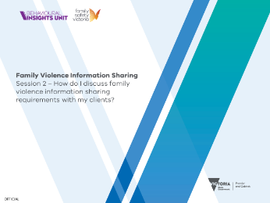

Session agenda (SLIDE 2)
1 minute

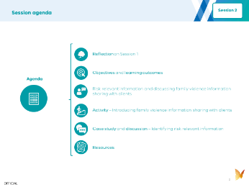
Instructions: Set expectations about what you’ll be covering by running through the agenda with your team.

Reflection on Session 1 (SLIDES 3 and 4)
3 minutes

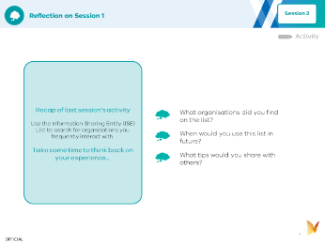

Instructions: To help your team with their learning, you should start this session with a recap and discussion of the activity from last week. Use the discussion prompts on Slide 4 to guide the conversation.

Objectives and learning outcomes (SLIDES 5, 6 and 7)
1 minute

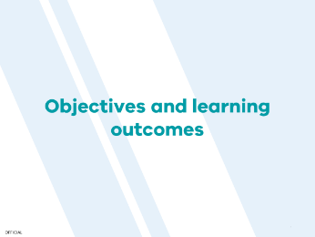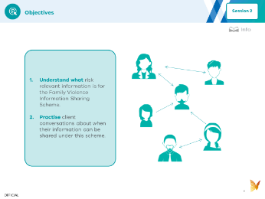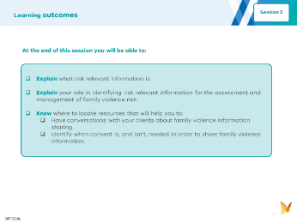

Instructions: Set expectations with your team about the objectives (Slide 6) and learning outcomes (Slide 7) for today.

Background (SLIDES 8, 9, 10 and 11)
10 minutes

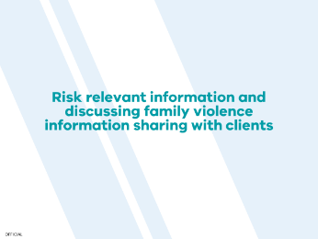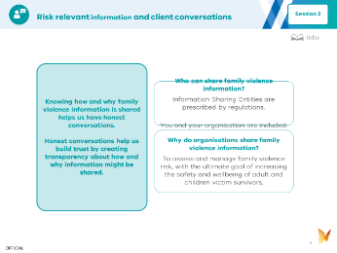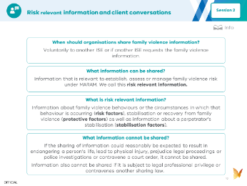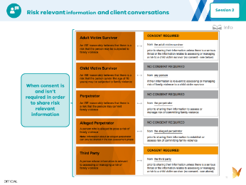

Instructions: You can use the following information to introduce your team to this week’s topic. It covers all the key points. You can read the notes below aloud, or adapt them to your own speaking style. The key points are outlined on the slides, and further details are provided in the speaking notes below, which expand on some of the key concepts.
Suggested speaking notes:
- Important context about family violence information sharing
  - It’s important that we maintain our trusted relationships with clients. To do this we need to know the fundamentals about family violence information sharing so we can have honest conversations about our legal requirements and reassure our clients that their safety and wellbeing is our priority.
- Who can share family violence information?
  - ISEs are authorised to share family violence information. These entities are prescribed by regulations.
  - In the last session we used the ISE List to search for organisations we frequently work with, which helps us to know who we can share family violence information with and request it from.
  - Organisations that are not listed as ISEs cannot have information shared with them or actively share information under the Family Violence Information Sharing Scheme, but may be able to share certain information under other legislation, such as privacy laws or Mandatory Reporting.
- Why do organisations share family violence information?
  - The Family Violence Information Sharing Scheme recognises that a victim survivor’s safety takes precedence over the perpetrator’s privacy . Specifically, information can be shared to:
    - Establish and assess family violence risk.
    - Manage family violence risk.
(SLIDE 10)
Suggested speaking notes:
When should organisations share family violence information?
- If you’re part of an ISE you:
  - Must share information in response to a request from another ISE.
  - Can share voluntarily with another ISE.
- You cannot share or request information through the Family Violence Information Sharing Scheme if you are not an ISE.
What family violence information can be shared?
- Risk relevant information can be shared between ISEs to establish, assess or manage family violence risk.
Risk Relevant Information
- Family violence information is regarded as risk relevant if it is information about family violence behaviours (risk factors) a perpetrator is using against an adult and / or children victim survivors or the circumstances in which that behaviour is occurring
- It also includes information related to an adult and / or child's stabilisation and recovery (protective factors) from family violence, as well as a perpetrator’s stabilisation (stabilisation factors).
- Risk and protective factors are unique to each case, however as an example, a very small subset of what they may include is provided below:
  - Risk factor examples against a victim survivor: Controlling behaviour, physical harm, history of family violence or emotional abuse by a perpetrator.
    - Note: Recent use of alcohol, drugs or other substances is considered a risk factor and is therefore risk relevant information.
  - Risk factor examples relevant to circumstances: Planning to leave or recent separation; escalation (increase in severity and/or frequency of violence).
  - Protective factor examples: Intervention order is in place and being adhered to, safe housing and social networks.
  - Stabilisation factor examples: Stabilisation of substance use and parole order.
- Risk relevant information is determined through applying knowledge from the Multi-Agency Risk Assessment and Management Framework (MARAM).
- What family violence information cannot be shared?
- There are two main reasons family violence information cannot be shared:
  - The information is classified as excluded information. This includes information that, if shared, would reasonably be expected to endanger a person’s life or result in physical injury, prejudice legal proceedings or a police investigation, contravene a court order, or is subject to legal professional privilege.
An example of excluded information would be sharing the address of a victim survivor where that could alert a person known to pose a threat to their whereabouts.
  - If the sharing contravenes another law that has not been specifically overridden by the scheme.
    - For example, information about the identity of a person who has made a protective intervention report to Child Protection or a wellbeing and safety report or referral to Child FIRST under the Children, Youth and Families Act 2005 should not be shared.
(SLIDE 11)
The people that family violence information can be shared about, and when consent is required
For the purposes of family violence information sharing, people have been categorised into five groups. These groupings are important because consent requirements differ depending on which group the person belongs to.
- Adult Victim Survivor: Someone that the ISE reasonably believes is at risk of experiencing family violence.
  - CONSENT REQUIRED (unless there is a serious threat or the risk relates to a child victim survivor)
- Child Victim Survivor: Someone that is under 18 years of age and the ISE reasonably believes is at risk of experiencing family violence.
  - NO CONSENT REQUIRED
- Perpetrator: Someone that the ISE reasonably believes is at risk of committing family violence.
  - NO CONSENT REQUIRED
- Alleged Perpetrator: Someone who is alleged to pose a risk of family violence. Note: information about an alleged perpetrator can only be shared with a Risk Assessment Entity for a family violence assessment purpose (not all ISEs are also RAEs so you will need to check this before sharing - this can be checked on the ISE List we used in the last session).
  - NO CONSENT REQUIRED
- Third Party: A person (other than the victim survivor or perpetrator) whose information is relevant to assessing or managing the risk of family violence. For example, a past partner of the perpetrator.
  - CONSENT REQUIRED (unless there is a serious threat or the risk relates to a child victim survivor)

Session activity (SLIDE 12, 13, 14 and 15)
30 minutes

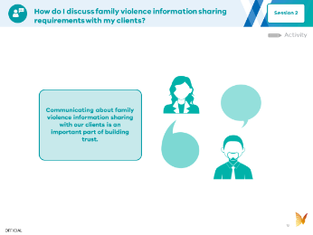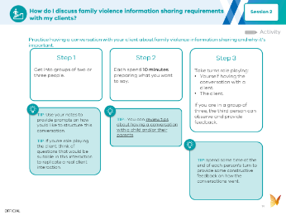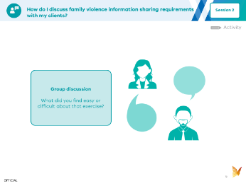
Instructions: Set the scene for the activity you will be completing as part of the session. This is about practising a conversation with your clients to build their confidence around family violence information sharing and will be done by role playing in small groups.

(SLIDE 14)

Instructions: Run through the steps in the activity before asking the team to break into small groups of 2-3 people to role play.
If this content is pretty new to your team, it’s a good idea to give them 5 minutes to read through the tip sheet and take notes before getting started.
If people are having trouble getting started, you may want to allocate them to groups and move between the groups to observe, help troubleshoot any issues and offer feedback.

(SLIDE 15)

Instructions: To help embed learnings from the activity, it’s a good idea to wrap up with a quick discussion.

Case study and discussion (SLIDE 16, 17 and 18)
10 minutes

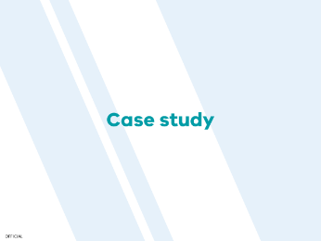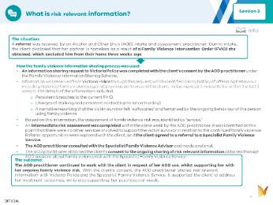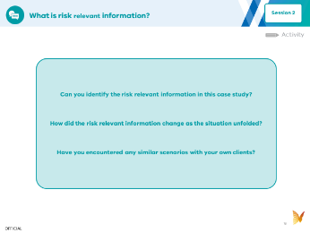
Instructions:
If you are running short on time, you can skip the case study and ask team members to read it in their own time.
A case study is provided to help your team understand family violence information sharing in the context of their work. Give your team members 5 minutes to read through this and then use the discussion prompts on Slide 18 to guide a conversation about it.

Resources (SLIDE 19, 20, 21 and 22)

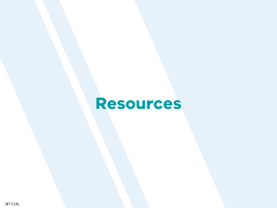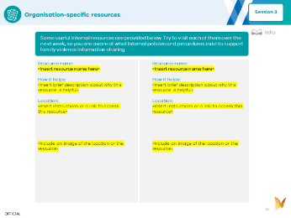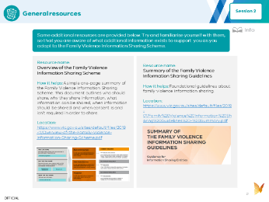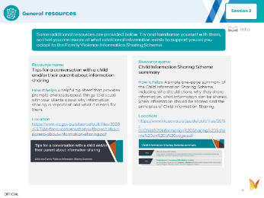
Instructions: These resources are included as they may be helpful to guide you and the team, if more information about identifying risk relevant information or having conversations with client about family violence information sharing is required. If you have time, you could run through the list of resources together, but you don’t have to go through them or read them today. They are provided for future reference.

