Family Violence Information Sharing
Team Leader Speaking Notes

Session 1: Family violence information sharing, why it’s important and Information Sharing Entities (ISEs) I can share with

Purpose of this document
This document is designed to be used by team leaders and sit alongside the PowerPoint slides for each session. Whereas the slides are designed to be shared with team members, this document includes instructions for you about the purpose of each slide as well as suggested speaking notes, where relevant.
We suggest that you review this material ahead of running sessions, and adapt the content as suits your personal style and approach.
The estimated time required to cover all the content is one hour. If you don’t have this much time available, you may wish to pick and choose which sections to cover based on the existing experience in your team.
For example:
- The Background section could be skipped or covered very briefly if your team already understands the basics of family violence information sharing and why it’s important.
- If your team already knows how to check if an organisation is an Information Sharing Entity, you may wish to focus on the Case study instead of the Activity.
Title slide (SLIDE 1)

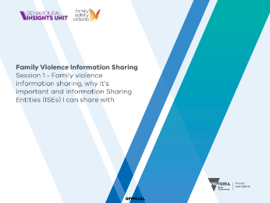

Session agenda (SLIDE 2)
1 minute

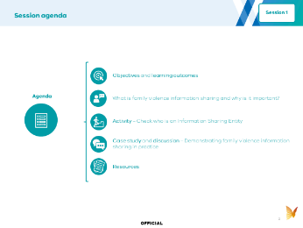
Instructions: Set expectations about what you’ll be covering by running through the agenda with your team.

Objective and learning outcomes (SLIDES 3, 4 and 5)
1 minute

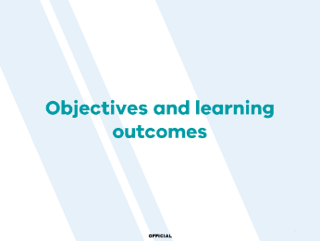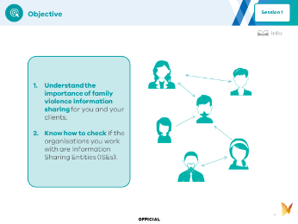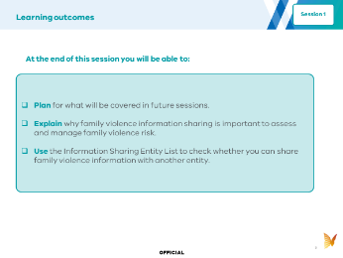
Instructions: Set expectations with your team about the objectives (Slide 4) and learning outcomes (Slide 5) for today.
Suggested speaking notes:
- Sharing information about family violence helps us and other organisations to better assess and manage family violence risk. The government has made new arrangements for sharing information about family violence to assess and manage risk. We’ll be covering how to put that into practice in our work over the next six sessions together.

Background (SLIDES 6, 7, 8, 9, 10 and 11)
20 minutes

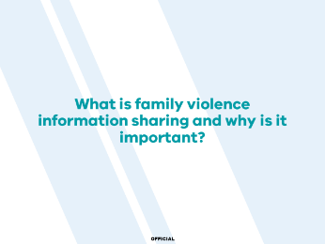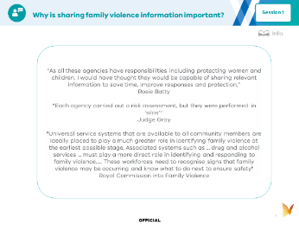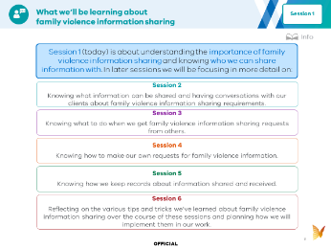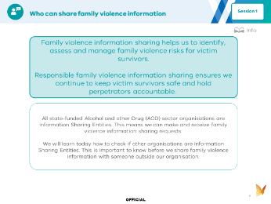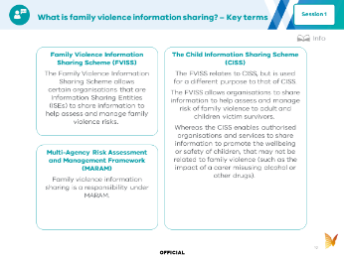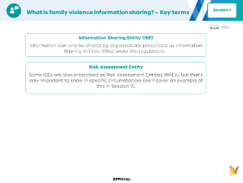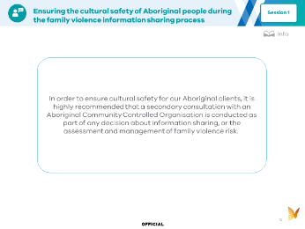
Instructions: You can use the following information to introduce your team to this week’s topic. It covers all the key points. You can read the notes below aloud, or adapt them to your own speaking style. The key points are covered in the slides, and further details are provided in the speaking notes below, which expand on some of those key concepts.
Suggested speaking notes:
(SLIDE 9)
Who can share family violence information?
- Under the Family Violence Information Sharing Scheme, our organisation is listed as an Information Sharing Entity (ISE).
- This means we are legally able to share information that is relevant to assessing and managing family violence risk. We’ll cover what types of information can be shared in future sessions.
- We can share family violence information with other organisations that are listed as ISEs.
- We cannot share information with organisations that are not listed as ISEs under the Scheme. However, there may be other permissions to share that information with other services. If you have been asked to share information or want to share proactively, with an organisation that is not an ISE, speak to your Manager about whether any other legal options apply.
- As the information sharing reforms are rolled out to more sectors, more organisations will be listed as ISEs. It is important to remember that this will change over time.
- In this session we’ll run through how to check the up-to-date list of ISEs.
(SLIDE 10 & 11)
What is family violence information sharing? – Key terms
- The Family Violence Information Sharing Scheme (FVISS) allows certain organisations and services that are Information Sharing Entities (ISEs) to share information to help assess and manage family violence risks.
- The Multi-Agency Risk Assessment and Management Framework (MARAM) ensures services are effectively identifying, assessing and managing family violence risk. Organisations prescribed in regulations must align their policies, procedures, practice guidance and tools to MARAM.
- The Child Information Sharing Scheme (CISS) enables organisations and services that are also prescribed as ISEs for CISS to share information to promote the wellbeing or safety of children, that may not be related to family violence (such as the impact of a carer misusing alcohol or other drugs).
- We are going to focus on sharing information about family violence, and so while it’s important to know that the Child Information Sharing Scheme exists, we won’t cover it in detail.
(SLIDE 12)
Ensuring the cultural safety of Aboriginal people during the family violence information sharing process
- An independent review identified concerns that the Family Violence Information Sharing Scheme raises the risk that women experiencing family violence would avoid or disengage from services to maintain their privacy, autonomy and, critically, to avoid Child Protection involvement. It would be expected that these concerns also apply to all Aboriginal clients.
- To ensure cultural safety for our Aboriginal clients, it is highly recommended that a secondary consultation with an Aboriginal Community Controlled Organisation is conducted as part of any decision about family violence information sharing, or the assessment and management of family violence risk.

Session activity (SLIDEs 13, 14, 15, 16 and 17)
20 minutes

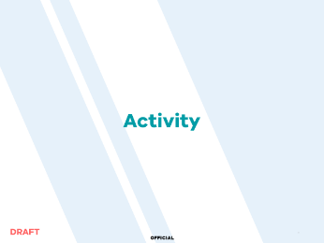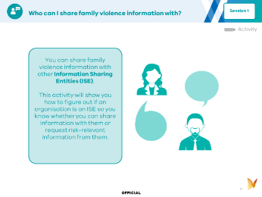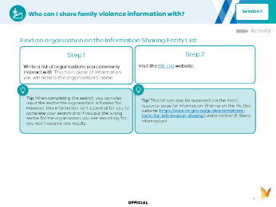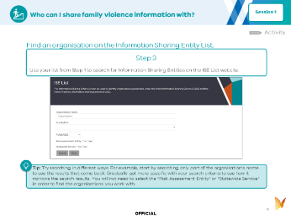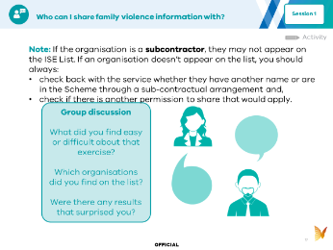
Instructions: Set the scene for the activity you will be completing as part of the session. This activity is about checking whether organisations are included on the Information Sharing Entity list, to determine whether you can share family violence information with them, or request family violence information from them.

(SLIDE 15 & 16)
Instructions: Run through the steps in the activity before asking the team to think about a list of organisations they engage with and then practice searching for those organisations.

You may want to demonstrate the search process first to get things going.
(SLIDE 17)
Instructions: To help embed learnings from the activity, it’s a good idea to wrap up with a quick discussion.

Case study and discussion (SLIDE 18, 19 and 20)
10 minutes

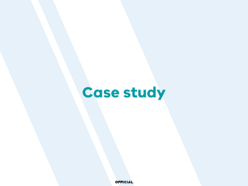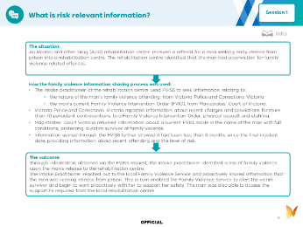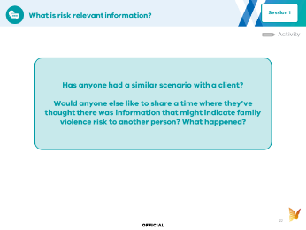
Instructions:
If you are running short on time, you can skip the case study and ask team members to read it in their own time.
A case study is provided to help your team understand family violence information sharing in the context of their work. Give your team members 5 minutes to read this and then use the discussion prompts on Slide 18 to guide a conversation about it.
As I flagged earlier today, we will be covering how and when family violence information is shared in later sessions.

Resources (SLIDE 21, 22 and 23)

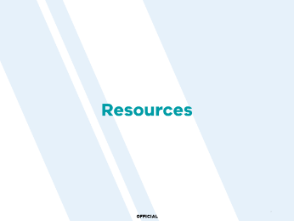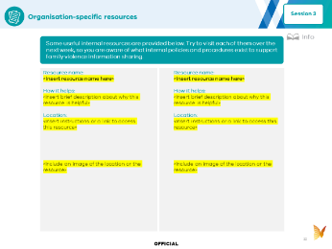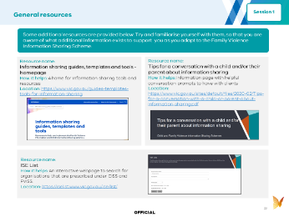
Instructions: These resources are included as they may be helpful to guide you if more information is needed about where to find guidance and resources about family violence information sharing. If you have time, you could run through the list of resources together in the session, but you do not have to go into them or read them today. They are provided as future reference.

